Document Title:  SOP-Storage-Hazardous Chemicals | Document Control No.:  [Enter Document Control No.] | Rev. No:  [Enter Revision No.]
Department:  [Enter Department] | Supersedes:  Original | Effective Date:  [Enter Date]
Prepared by:  [Affix Name, Signature, Position Title] | Reviewed by:  [Affix Name, Signature, Position Title] | Approved by:  [Affix Name, Signature, Position Title]
Date: [Enter Date] | Date: [Enter Date] | Date: [Enter Date]

- Purpose:
  - To provide general safety procedures for safe handling and storage of hazardous chemicals

- Frequency:
  - At all times
  - [ADD FREQUENCY HERE]

- Equipment:
  - Personal Protective Equipment
  - [ENTER LIST OF EQUIPMENT HERE]

- Consumable:
  - None
  - [ENTER LIST OF CONSUMABLES HERE]

- Responsibility:
  - Supervisors or department heads and team leaders
    - Ensure that the proper procedures are followed for handling and storage of such chemicals
    - Ensures that personnel are trained to handle chemicals and that all chemicals are stored in a safe manner
  - Qualified Personnel
    - Handle all hazardous materials.
  - [ADD OR CUSTOMIZE RESPONSIBLE PERSON HERE]

- Procedure/Instructions:
  - Storage of Hazardous Chemicals
    - Chemical storage areas comply with local or national regulations, are designed to contain spillages, and are ventilated, secure and lockable. Only EPA-approved and authorized chemicals are to be stored.
    - Follow the manufacturer’s directions for specific mixing, storing, and first aid instructions on the chemical containers in the MSDS.
    - Label and date all poisonous or toxic chemicals with the common name of the substance with the labels facing out so they can be easily read. Labels include the name of the chemical constituent(s) and any hazards present.
    - Replace any labels that are deteriorating or falling off and/or relabel them with another label before the chemical becomes an unknown.
    - Older containers are stored in front of newer chemicals, and containers with the least chemicals are stored in front of full containers. This allows older chemicals to get used up first and helps minimize the number of chemical containers in the storage area.
    - Store chemicals in their original containers or transfer them to specifically designed bulk storage units that are correctly labeled.
    - Keep all containers of chemicals closed when not in use.
    - In general, and where practical, no chemicals are stored above eye level.
    - Segregate and store chemicals according to compatibility and hazard classes.
    - If separate storage is not possible, ensure that there is a visible means of separation of these groups of chemicals or toxic substances. Store pest management chemicals (toxic) separately from cleaning chemicals and separate from engineering chemicals (hazardous). Do not store these different chemicals on the same shelf or above each other on the same rack.
    - Store toxics separately, away from processing and handling areas, eating areas, and protective equipment storage.
    - Do not store chemicals in direct sunlight or next to heat sources.
    - Limit access to chemicals by using locks, seals, or key cards.
    - List all stored chemicals in the inventory.
    - Place visible signage indicating the storage area as hazardous.
    - Always keep spill kits and other spill control equipment on hand in areas where chemicals are used.
  - Segregating Hazardous Chemicals
    - Store chemicals by hazard classification; avoid storing chemicals alphabetically unless they are compatible or already separated into appropriate hazard classes - this ensures that incompatible chemicals are segregated.
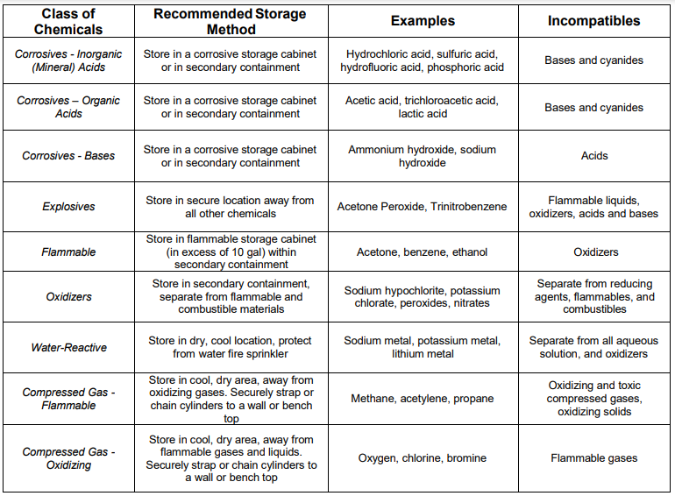
    - Accidental contact between incompatible chemicals can result in a fire, an explosion, the formation of highly toxic and/or flammable substances, or other potentially harmful reactions. If incompatible chemicals are stored in the same cabinet, provide physical segregation (secondary containment).
  - [ADD OR CUSTOMIZE PROCEDURES/ INSTRUCTIONS HERE]

- Corrective Action
  - In case of a fire, explosion, or gas leak, evacuate individuals from the area and call the emergency response (911). Notify supervision and adjacent personnel as quickly as possible.
  - In case of a chemical spill, alert others in the immediate vicinity and notify your supervisor.
  - Discard any food contaminated by chemicals.
  - Label and properly store any unlabeled or misplaced chemicals.
  - [ADD OR CUSTOMIZE CORRECTIVE ACTIONS HERE]

- Related Forms:
  - Chemical Inventory Log
  - Register-Hazardous Chemical
  - [ADD OR CUSTOMIZE RELATED FORMS HERE]

- History/Changes:
Revision No.: | Revision Date: | Description of Change: | Originator / Author Name: | Title / Department:
0 | YYYYMMDD | Original | ENTER AUTHOR NAME | ENTER TITLE/ENTER DEPARTMENT

*Should you need assistance in customizing this document please email services@consultareinc.com

